Task 1:

Write Algo for AVL tree

- Create a new node with the given key or value.
- Check if the tree is empty:
  - If yes, make the new node the root of the tree.
  - If no, proceed to the next step.
- Insert the node using standard Binary Search Tree (BST) logic (left if smaller, right if greater).
- After insertion, update the height of each ancestor node and calculate its balance factor.
- If the balance factor of any node is outside the range [-1, 1], the tree is unbalanced:
  - Perform the appropriate rotation(s) (LL, RR, LR, RL) to restore balance.
- Repeat this process recursively up the tree until all nodes are balanced.

Task 2:

Write code for AVL tree

Hint: try to insert nodes
While inserting get the balance of the tree
Create 2 methods for left rotate and right rotate
Try to insert
Finally display
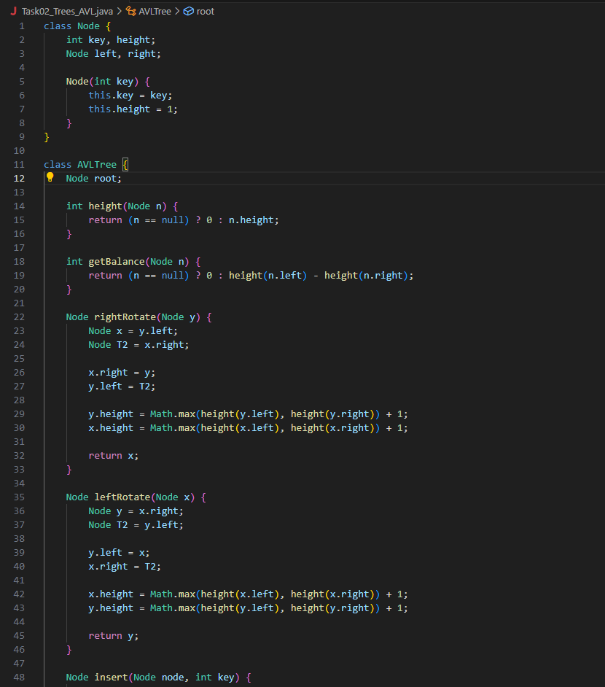
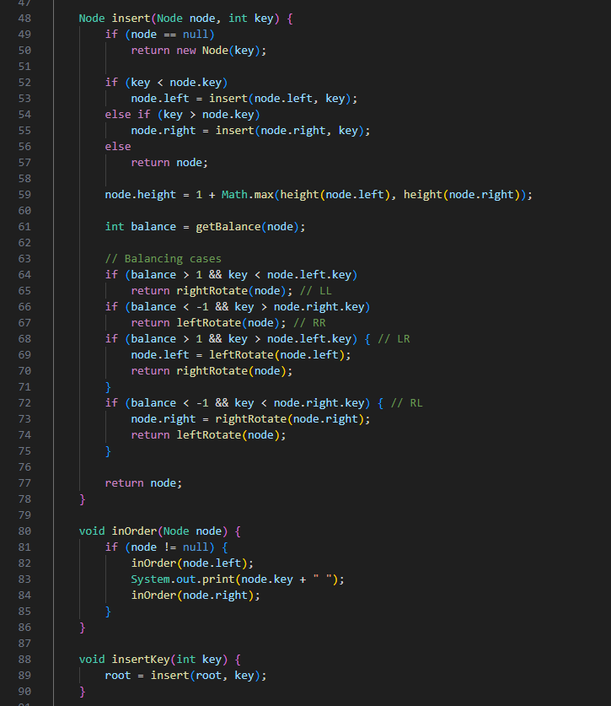
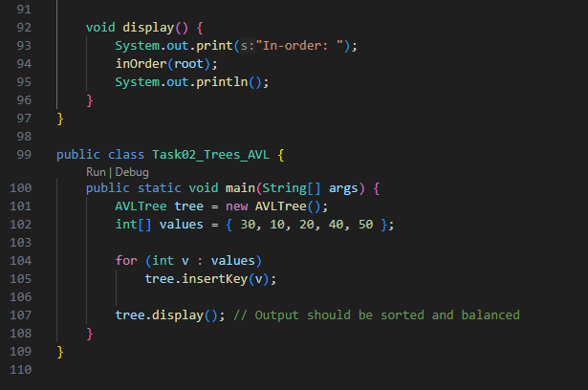
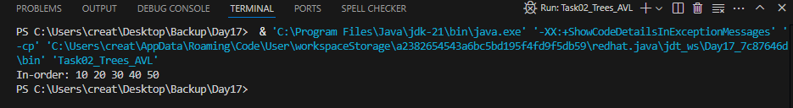

Task 3:
1.If the tree is empty, insert the new node as root and color it black
2.If the tree is not empty, insert the new node as a leaf and color it red
3.If the parent of the new node is red and the parent’s sibling (uncle) is also red:
- Change the color of parent and uncle to black
- Change the color of grandparent to red
- If the grandparent is root, keep it black
4.If the parent is red and the uncle is null or black:
- Perform a rotation to fix the red-red conflict
- Rotation type depends on the position of the new node (LL or LR)
5.Left-Left rotation is used when the new node is the left child of a left parent
- Promote the parent and demote the grandparent
- Make the parent black and grandparent red
6.Left-Right rotation is used when the new node is the right child of a left parent
- Rotate left at parent, then right at grandparent
- Adjust colors based on position
7.Rotations are applied only when the parent is red and the uncle is null or black

